**Option 1 Example**

**When are Triangles Equal?**

**Lesson Outcomes:** Students should be able to identify when two triangles are similar and when two triangles are congruent.

**Materials:** Paper cut into the shapes of triangles (diagrams below), writing materials so students can draw their own triangles.

**The Lesson**

**Motivation (10 - 15 minutes)**: Show students the triangles below. (These should be cut out for students, so the students can interact with them).

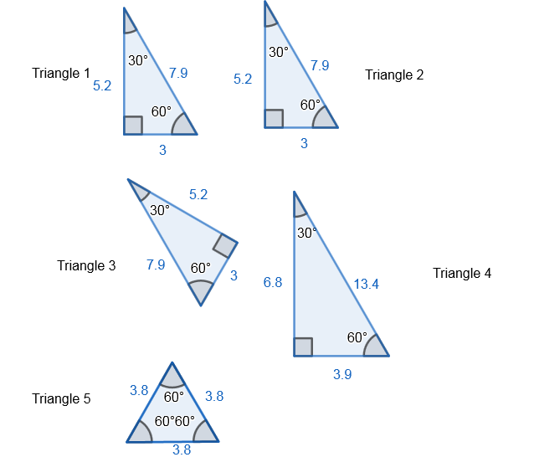

Ask the students which of these triangles are the same, and why. Responses might include:

1. None of these triangles are the same, since each is translated differently.
2. None of these triangles are the same, since they each have a different name.
3. Triangles 1,2 are the same, since they have the same angles, same side lengths, and are not rotated.
4. Triangles 1,2,3 are the same since they are rotations, reflections, or translations of each other.
5. Triangles 1,2,3,4 are the same, since they have the same angles.

Certainly each of these responses is valid, as we have not been very clear about what we mean by "the same". Ask students which notions of "sameness" might be helpful to us when describing triangles.

**Congruence (15-20 minutes)**: The first type of "sameness" that we may find useful is congruence. We say triangles $∆ABC≅∆DEF$ when each of these triangles has the same angles and the same size lengths. In other words, each triangle has the same angles and the same size. Two triangles that are reflections, rotations, and/or translations of each other are still congruent as they have the same angles and size. In the above triangles, Triangle 1, Triangle 2, and Triangle 3 are all congruent. If you do not know all of the triangle's angles and sides, it may still be possible to determine whether two triangles are congruent.

Consider $∆ABC,∆DEF$

**SSS (Side-Side-Side)**: If two triangles have all three side sharing the same lengths, then the two triangles are congruent. For our triangles, this means if

$$\overline{AB}≅\overline{DE},\overline{BC}≅\overline{EF},\overline{AC}≅\overline{DF}$$

then

$$∆ABC≅∆DEF$$

**ASA (Angle-Side-Angle)**: If two triangles share two of the three angles and share one side (assuming the side takes the same location relative to both triangles), then the two triangles are congruent. For our triangles, this means if

$$⦣ABC≅⦣DEF,⦣BCA≅⦣EFD,\overline{AB}≅\overline{DE}$$

then

$$∆ABC≅∆DEF$$

In fact, this rule works for any side. If we know

$$⦣ABC≅⦣DEF,⦣BCA≅⦣EFD,\overline{BC}≅\overline{EF}$$

then

$$∆ABC≅∆DEF$$

**SAS (Side-Angle-Side)**: If two triangles have two sides that are the same and the angle **between** the two sides is identical in both triangles, then both triangles are congruent. If the angle is not between the two sides, this does not guarantee congruence. If you try using ASS (angle-side-side) rule, it will not work (There is a possible mnemonic here for students, if you wish to share). Make sure that it is clear to students that ASS does not work like SAS does. For our triangles, this means if

$$⦣ABC≅⦣DEF,\overline{AB}≅\overline{DE},\overline{BC}≅\overline{EF}$$

then

$$∆ABC≅∆DEF$$

However if we have

$$⦣ABC≅⦣DEF,\overline{AB}≅\overline{DE},\overline{AC}≅\overline{DF}$$

this does not tell us whether or not $∆ABC≅∆DEF$.

**Similarity (15-20 minutes)**: The second type of "sameness" that we may find useful is congruence. We say triangles $∆ABC\sim ∆DEF$ when each of these triangles has the same angles but not necessarily the same size lengths. In other words, each triangle has the same angles but maybe different sizes. Two triangles that are reflections, rotations, dilations, and/or translations of each other are still similar as they have the same angles. This means all congruent triangles are similar triangles, but two similar triangles might not be congruent. In the above triangles, Triangle 1, Triangle 2, Triangle 3, and Triangle 4 are all similar. If you do not know all of the triangle's angles and sides, it may still be possible to determine whether two triangles are similar.

**SSS (Side-Side-Side)**: If two triangles have all three pairs of corresponding sides proportional in length, then these two triangles are similar. For our triangles this means if

$$\frac{AB}{DE}=\frac{BC}{EF}=\frac{AC}{DF}$$

then

$$∆ABC\sim ∆DEF$$

**AA (Angle-Angle)**: If two triangles share two of the three angles then the two triangles are similar. For our triangles, this means if

$$⦣ABC≅⦣DEF,⦣BCA≅⦣EFD$$

then

$$∆ABC\sim ∆DEF$$

**SAS (Side-Angle-Side)**: If two triangles have two sides that are the same and the angle **between** the two sides is identical in both triangles, then both triangles are congruent. If the angle is not between the two sides, this does not guarantee congruence. If you try using ASS (angle-side-side) rule, you will make an ASS (angle-side-side) out of yourself. (Assuming the students are old enough for this mnemonic joke). Make sure that it is clear to students that ASS does not work like SAS does. For our triangles, this means if

$$⦣ABC≅⦣DEF,\frac{AB}{DE}=\frac{BC}{EF}$$

then

$$∆ABC\sim ∆DEF$$

However if we have

this does not tell us whether or not .